Web Service

A **Web Service** is can be defined by following ways:

* It is a client-server application or application component for communication.
* The method of communication between two devices over the network.
* It is a software system for the interoperable machine to machine communication.
* It is a collection of standards or protocols for exchanging information between two devices or application.

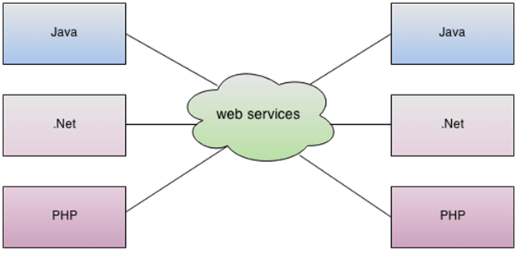

 For example, the Java application can interact with Java, .Net, and PHP applications. So web service is a language independent way of communication.

How Web Services Work?

## 032316_0646_Webservicea1.png

The main component of a web service design is the data which is transferred between the client and the server, and that is XML. XML (Extensible markup language) is a counterpart to HTML and easy to understand the intermediate language that is understood by many programming languages.

So when applications talk to each other, they actually talk in XML. This provides a common platform for application developed in various programming languages to talk to each other.

Why do you need a Web Service?

Modern day business applications use variety of programming platforms to develop web-based applications. Some applications may be developed in Java, others in .Net, while some other in Angular JS, Node.js, etc.

Most often than not, these heterogeneous applications need some sort of communication to happen between them. Since they are built using different development languages, it becomes really difficult to ensure accurate communication between applications.

Here is where web services come in. Web services provide a common platform that allows multiple applications built on various [programming languages](https://www.guru99.com/best-programming-language.html) to have the ability to communicate with each other.

## Types of Web Services

There are mainly two types of web services.

1. SOAP web services.
2. RESTful web services

SOAP Web Services

SOAP stands for Simple Object Access Protocol. It is a XML-based protocol for accessing web services.

SOAP is a W3C recommendation for communication between two applications.

SOAP is XML based protocol. It is platform independent and language independent.

**Language and Platform independent**: SOAP web services can be written in any programming language and executed in any platform.

**Slow**: SOAP uses XML format that must be parsed to be read. It defines many standards that must be followed while developing the SOAP applications. So it is slow and consumes more bandwidth and resource.

RESTful Web Services

REST stands for REpresentational State Transfer.

REST is an architectural style not a protocol.

**Fast**: RESTful Web Services are fast because there is no strict specification like SOAP. It consumes less bandwidth and resource.

**Language and Platform independent**: RESTful web services can be written in any programming language and executed in any platform.

**Permits different data format**: RESTful web service permits different data format such as Plain Text, HTML, XML and JSON

Difference between SOAP & REST

|  |  |  |
| --- | --- | --- |
| **No.** | **SOAP** | **REST** |
| 1) | SOAP is a **protocol**. | REST is an **architectural style**. |
| 2) | SOAP stands for **Simple Object Access Protocol**. | REST stands for **REpresentational State Transfer**. |
| 3) | SOAP **can't use REST** because it is a protocol. | REST **can use SOAP** web services because it is a concept and can use any protocol like HTTP, SOAP. |
| 4) | SOAP **uses services interfaces to expose the business logic**. | REST **uses URI to expose business logic**. |
| 5) | **JAX-WS** is the java API for SOAP web services. | **JAX-RS** is the java API for RESTful web services. |
| 6) | SOAP **defines standards**to be strictly followed. | REST does not define too much standards like SOAP. |
| 7) | SOAP **requires more bandwidth** and resource than REST. | REST **requires less bandwidth** and resource than SOAP. |
| 8) | SOAP **defines its own security**. | RESTful web services **inherits security measures** from the underlying transport. |
| 9) | SOAP **permits XML** data format only. | REST **permits different** data format such as Plain text, HTML, XML, JSON etc. |
| 10) | SOAP is **less preferred** than REST. | REST **more preferred** than SOAP. |